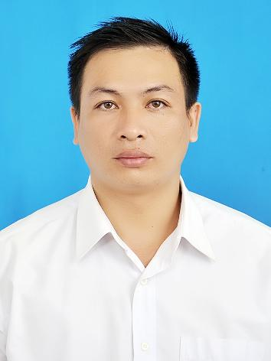**CURRICULUM VITAE**

**PERSONAL PARTICULARS**

**Full Name:** **HUYNH THAI HOC**

**Date of Birth:** 18th October, 1982 **Gender:** male

**Place of Birth:** Ca Mau – Vietnam **Nationality:** Vietnamese

**Weigh:** 60Kg **High:** 168 cm

**Place of Residence:** 393D, Ly Thuong Kiet Street, 6 Ward, Ca Mau City

**Cell Phone:** 01257891148.

**Email:** huynhthaihoc82@gmail.com

1. **EDUCATION INFORMATION**

**1994 – 1996:** Studied in Tran Van Thoi School, Tran Van Thoi district of Ca Mau town.

**1996 – 2001:** Studied in high school, Ca Mau city.

**2002 - 2004:** Studied in Hanoi Technical Reconnaissance College with main brand is Technical Reconnaissance and Radio Cryptography.

1. **LANGUAGES AND INFORMATICS**

**English:**  Moderately good.

**Computer Literacy:**

# Microsoft Office: World, Excel

* Easy using and familiar with new other software

1. **PROFESSIONAL EXPERIENCES**

**2004 –2009:** worked for Vietnam Army with military rank of sublieutenant .

**2010-2013:** worked for the local army.

**12/6/2014-11/11/2015**: worked for PVD Baker Hughes (Petro Viet Nam Drilling Join Venture Company )

with Store man position.

**14/4/2017/-14/7/2017**: work for Nam Nghi Resort with bell man position.

*Job Description:*

* *Drive Buggy and arrange luggage for the guest.*
* *Take care the guest.*

*-Delivery and Receiving goods.*

*- Importing and Exporting goods*

*- Knowledge about Certifications :COO (Certificated Of Ogion), TC( Test Certificated), Air Way Bill, Commercial Invoice, Packing List, Warrently Letter.*

*- check out and in shiping Inventory( Accessories, spare parts).*

* Radio operator.
* Technical Reconnaissance via radio system.
* Radio communication and process to encode and decode signals.

**PERSONAL ABILITY.**

* Can work in position: Warehouse Supervisor, a Staff ,Bell man.
* Can work in Radio operator position, document controller, deck crew or M&R technician.
* Ability to work independently or work in team.
* Creativity, honesty, reliability, diligence, friendliness and harmony.
* Ability to work under pressure and meet targets.

1. **INTERESTS AND ACTIVITIES**

*Hobbies:* Travelling and playing football, badminton ,go Fishing.

*Desired Workplace:* Oil & Gas Field ,Warehouse, – Vungtau , Ho Chi Minh city , Bell Man, Bell Captain in Phu Quoc Island.

1. **CERTIFICATION:**

* I signed below to certify this data is correctly described my qualification, my experience and myself.
* I understand that any willful statement described herein may lead to my disqualification or dismissal if employed.

**Ca Mau date:7/9/2017.**

The declarant.